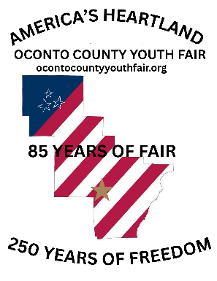
Oconto County Fair
Open Entry Form

Mail entries to: Stacie Pienta, 9377 County Rd CC, Oconto Falls, WI 54154
- Entries must be received no later than 10 days prior to Fair entry day.

Pre-entry is preferred however Open Division entries will be accepted during the following times at the Fair Exhibit Building:
- 4 p.m. - 7 p.m. Monday of the Fair
- 9 a.m. - 11 a.m. Tuesday of the Fair
ABSOLUTELY NO OPEN CLASS ENTRIES WILL BE ACCEPTED AFTER 11 A.M. ON TUESDAY

Entry Type: Please check the box for the division you are entering:
Senior Citizen Open Adult Open Junior Open
Name: __________________________________________________________ Age: ________
Address: _______________________________________________________________________________
Phone: _______________________________ Email: ___________________________________________
Dept # | Class | Lot # | Description of Item to be Exhibited

- Exhibitors must read general, division, and department rules and requirements to be sure they are met.
- Exhibitors may print additional entry forms if needed or use lined paper for additional entries.

By entering, I certify I have read and agree to abide by all rules of the Fair.

Signature of Exhibitor: ________________________________________ Date: ________________

